H.T No
Regulations:
A17


Sreenidhi Institute of Science and Technology
(An Autonomous Institution)
Code No: 6BC03 Date: 03-Feb-2020 (FN)

B.Tech I-Year II-Semester External Examination, Jan/Feb-2020 (Supplementary)
ENGINEERING MECHANICS (CIVIL and ME)

Time: 3 Hours Max.Marks:75

Note: a) No additional answer sheets will be provided.
b) All sub-parts of a question must be answered at one place only, otherwise it will not be valued.
c) Missing data can be assumed suitably.

Part - A Max.Marks:25

Answer all QUESTIONS.

1. | Explain the law transmissibility of force. | [3M]
2. | Write laws of friction. | [3M]
3. | Explain perfect truss and redundant truss. | [3M]
4. | Differentiate between centroid and center of gravity. | [3M]
5. | State parallel axis theorem. | [3M]
6. | State D’Alemberts principle. | [2M]
7. | State parallelogram law of forces. | [2M]
8. | State Pappus theorem. | [2M]
9. | What is radius of gyration? | [2M]
10. | Differentiate between moment and couple. | [2M]
Part – B Max.Marks:50
ANSWER ANY FIVE QUESTIONS. EACH QUESTION CARRIES 10 MARKS.

11. |  | Two cylinders A and B rest in a box as shown in Fig. A has a diameter of 300 mm and weighs 1200 N. B has a diameter of 200 mm and weighs 360 N. The box is 450 mm wide at the bottom. Assume that all surfaces are smooth. Find the reactions at the supporting surfaces.  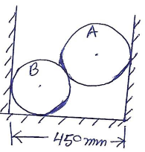 | [10M]
12. |  | What is the value of P in the system shown in Fig. to cause the motion to impend? Assume the pulley is smooth and coefficient of friction between the other contact surfaces is 0.2.  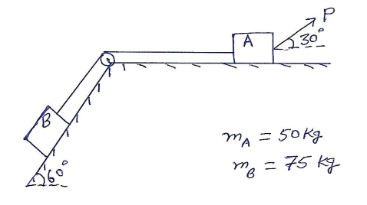 | [10M]
13. |  | Determine the forces in all the members of the frames shown in Fig.  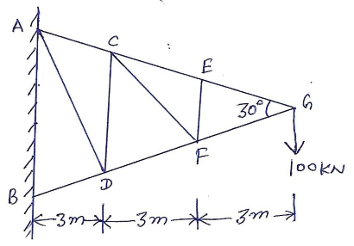 | [10M]
14. |  | The position of the particle is given by the relation S=1.5t³-9t²-22.5t+60, where S is expressed in meters and t in seconds. Determine (i) the time at which the velocity will be zero (ii) the position and distance travelled by the particle at that time (iii) the acceleration of the particle at that time and (iv) the distance travelled by the particle from t = 5s to t = 7s. | [10M]
15. |  | Find the moment of inertia of the area shaded in Fig. about the axis AB.  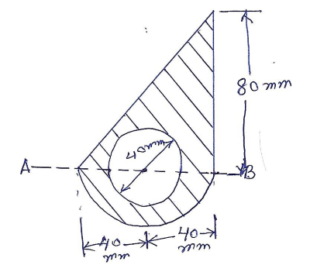 | [10M]
16. |  | Two rough planes inclined at 30⁰ and 60⁰ to horizontal are placed back to back as shown in Fig. The blocks of weights 50 N and 100 N are placed on the faces and are connected by a string running parallel to planes and passing over a frictionless pulley. If the coefficient of friction between planes and blocks is 1/3, find the resulting acceleration and tension in the string.  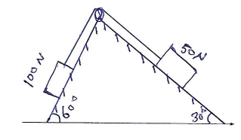 | [10M]
17. |  | Find the reactions at the supports A and B in the beam AB shown in Fig.  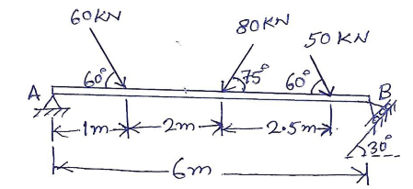 | [10M]
18. |  | Determine the coordinates Xc and Yc of the center of a 100 mm diameter circular hole cut in a thin plate so that this point will be the centroid of the remaining shaded area shown in Fig. (All dimensions are in mm)  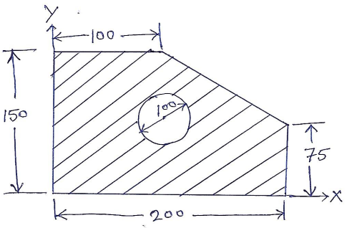 | [10M]

-- 00 -- 00 –

